Lesson 05 Demo 04

Configuring VNet Peering

Objective: To configure VNet peering between two virtual networks

Tools required: None

Prerequisites: Two virtual networks should already be created. (Create different IP addresses for virtual networks)

Steps to be followed:
- Configure VNet peering on the first virtual network
- Configure VNet peering on the second virtual network

Step 1: Configure VNet peering on the first virtual network

- In the Azure Portal, select the first virtual network (VNet1)

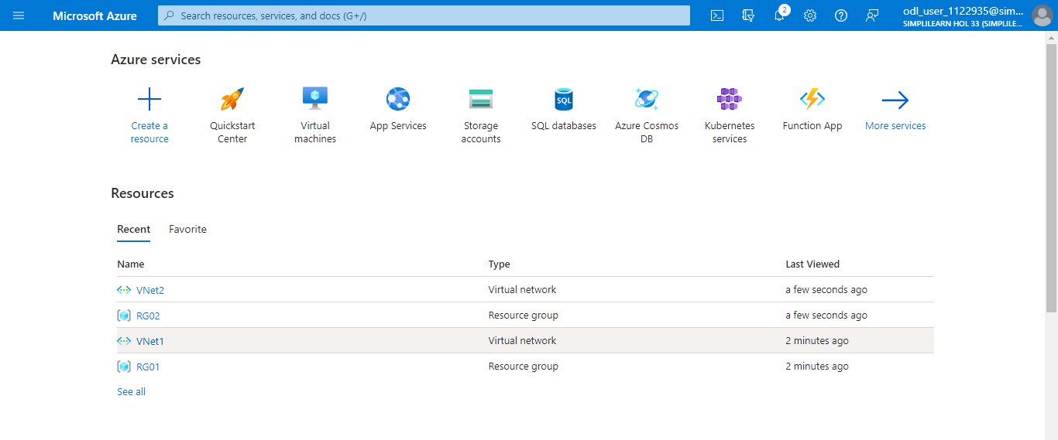

- Under Settings, select Peerings and click on + Add

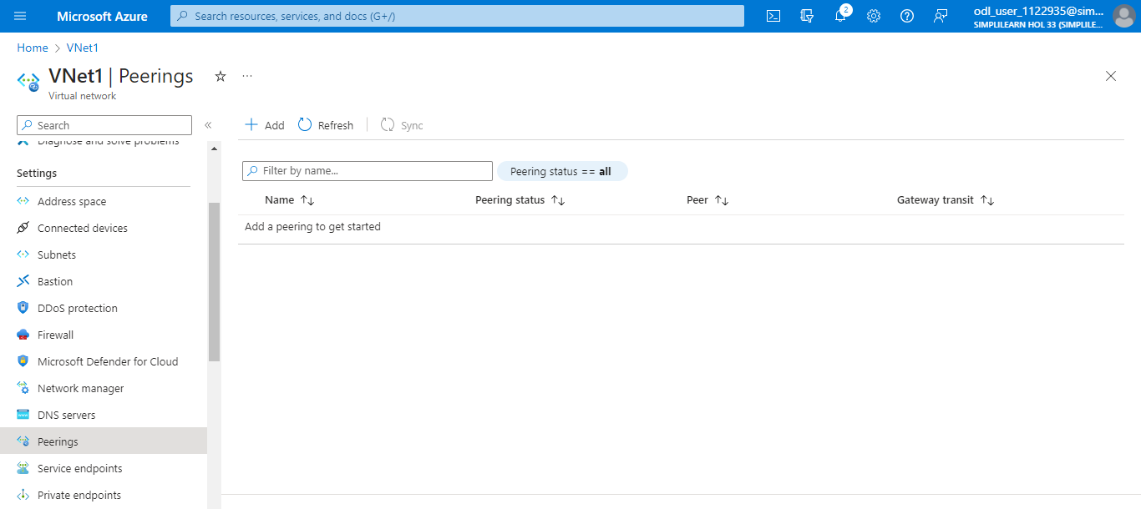

  - Provide a Peering link name under This virtual network and Remote virtual network

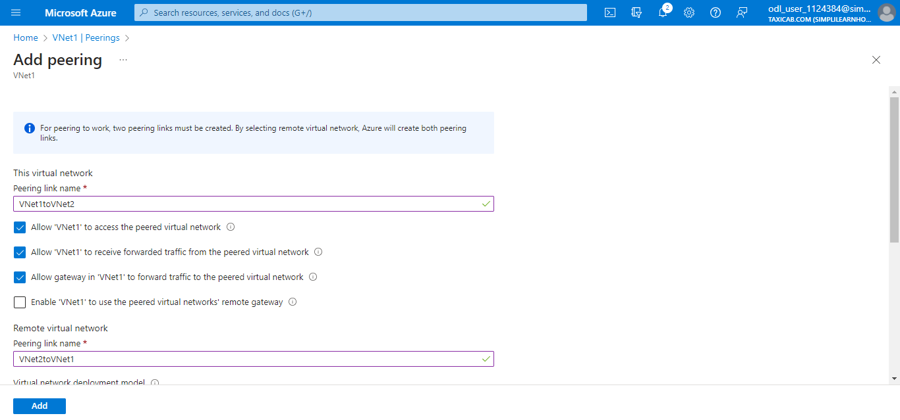

  - In the Virtual network dropdown, select the remote virtual network and ensure the
correct Subscription is chosen

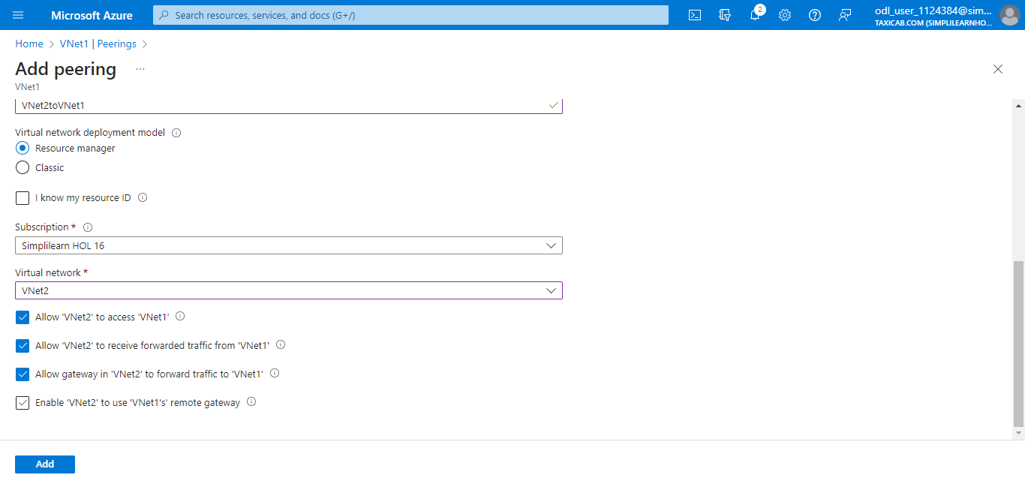

Now, the Peering status shows Connected in the screenshot below:

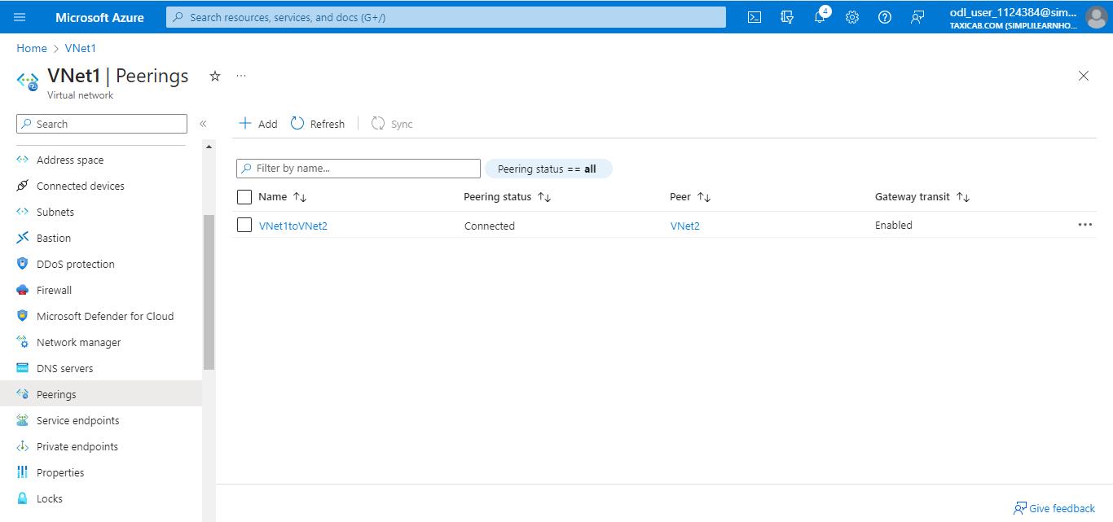

Step 2: Configure VNet peering on the second virtual network

  - In the Azure portal, select the second virtual network (VNet2)

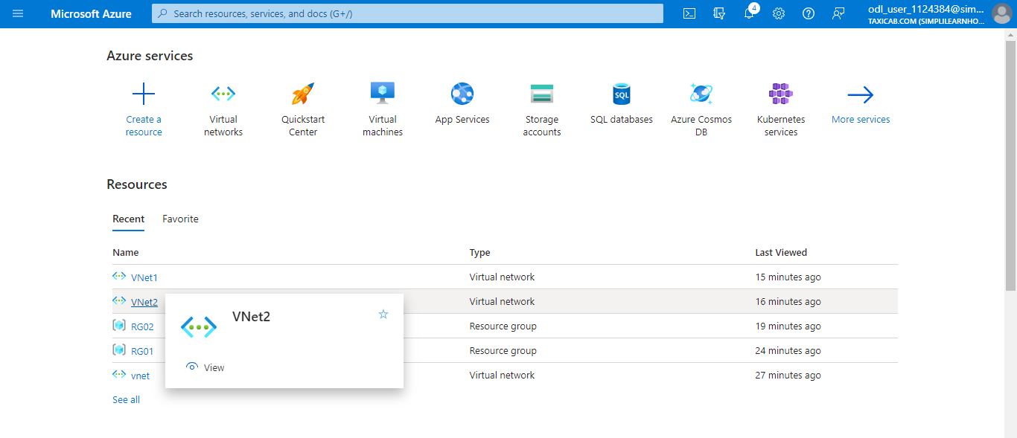

  - Under Settings, choose Peerings

Note:
The peering connection you named in the first virtual network configuration
is now automatically established and marked as Connected.

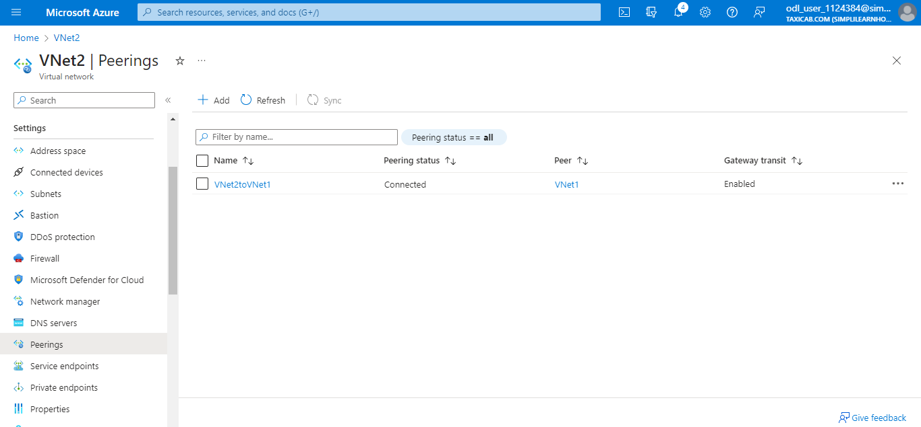

You have successfully configured peering between two virtual networks together so that resources in one virtual network can talk to resources in the second virtual network.

